Project Name:

ONLINE BANKING SYSTEM

Date: <<28/12/2022>>

Copyright Notice

This document contains proprietary information of HCL Technologies Ltd. No part of this document may be reproduced, stored, copied, or transmitted in any form or by means of electronic, mechanical, photocopying or otherwise, without the express consent of HCL Technologies. This document is intended for internal circulation only and not meant for external distribution.

**Revision History: -**

|  |  |  |  |
| --- | --- | --- | --- |
| **Version No** | **Date** | **Prepared by** | **Significant Changes** |
| 1.0 | 28/12/2022 | Shankar Kondeti |  |
|  |  |  |  |

**Table Of Contents**

1.1 Project Overview 3

1.2 Scope 3

1.3 Out of Scope 3

1.4 Intended Audience 3

1.5 Use Cases detailed 3

1.6 Technical Architecture 3

1.7 Database Entity Relationship Diagram 3

1.8 Standards 3

1.9 Requirements……………………………………………………………………………………………………………………….3

**1.1 Project Overview**

The objective of the test is to verify that the functionality of ONLINE BANKING SYSTEM – login, add and remove account, deposit and withdrawal of money and transaction modules. 

**1.2 Scope**

* Verify login.
* Verify add savings and remove savings account.
* Verify deposit and withdraw.

**1.3 Out of Scope**

* Automation testing
* Performance testing

**1.4 Intended Audience**

The Online Banking suite provides a global accounting foundation that provides the all private banks with electronic banking facilities. It allows client of private banks to carry out their day to day banking transactions. It is for age group above 18.

**1.5 Use Cases Detailed**

**1.6 Technical Architecture**

**IDE:**

My Eclipse

**Front End:**

JDBC, JavaScript

**Programming Language:**

JAVA

**Back End:**

Oracle 11g

**1.7 Database Entity Relationship Diagram**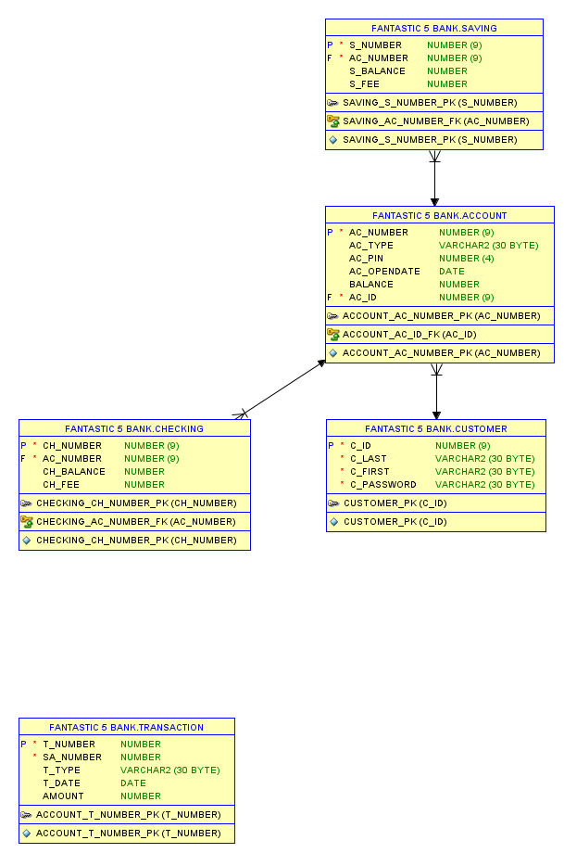

**1.8 Standards**

#### **JAVA: -**

#### **Variable Scopes, Readability, and Lambda Expression. In Java, every variable declared has a scope.**

#### **Class Fields.**

#### **Treating Method Arguments as Local Variables.**

#### **Boxing and Unboxing.**

#### **Interfaces.**

#### **Strings.**

#### **Naming Conventions.**

#### **Standard Libraries.**

#### **JDBC: -**

#### **Importing Packages.**

#### **Opening a Connection to a Database.**

#### **Creating a Statement Object.**

#### **Running a Query and Retrieving a Result Set Object.**

#### **Processing the Result Set Object.**

#### **Closing the Result Set and Statement Objects.**

#### **Making Changes to the Database.**

* **About Committing Changes.**

**1.9 Requirements**

**R_01: -** Validating Login module functionality.

**R_02: -**  Validating Display account details module functionality.

**R_03: -** Validating Add Saving account module functionality.

**R_04: -** Validating Delete Saving account module functionality.

**R_05: -**  Validating Transactions module functionality.

**R_06: -** Validating Exit Module functionality.

* Customer id should be 9 digits.
* Customer password should not exceed 30 words.
* Account id should be 9 digits.
* Account number should be 9 digits.
* Account pin should be 4 digits.
* Saving number should be 9 digits.
* Checking number should be 9 digits.